
FACT SHEET
(Fiscal Year 2018-2019)

Founded: 1966

Mission Statement: “We give everyone the opportunity to learn and develop the right skills so lives and communities are strengthened.”

Colleges: 23 College Location Map) hyperlink

Campuses: 40

Leadership: Virginia State Board for Community Colleges
Glenn DuBois, Chancellor (2002-present)

Headquarters: 300 Arboretum Place, Suite 200
Richmond, Virginia 23236
info@vccs.edu

Degrees, Diplomas &
Certificates Earned
(2018-2019): 32,617

Student Population
& Demographics: 228,135 total degree/diploma-seeking students
- 99,590 minority students (44%)
- 29,345 military-related students (13%)
- 40,719 first generation students (18%)
- 43% Male
- 57% Female
- Average Age: 24.16 years old (credit students)
- 23,100 high school students received career coaching
- 45,486 high school students earned college credit through dual enrollment
- 56% of students took at least 1 course via distance learning
technologies

Workforce Training &
Community Education
Students Served: 52,917

Value of Scholarships
Awarded (2017-2017): $9,213,553

Bachelor’s Degree
Tuition Savings: Up to $38,000 in savings by completing an associate degree first at a VCCS college and taking advantage of statewide Guaranteed Articulation Agreements.

VCCS College Locations and Website Links
(in alphabetical order)

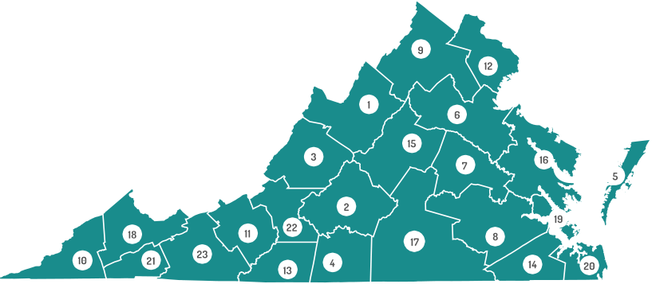
- Blue Ridge Community College
- Central Virginia Community College
- Dabney S. Lancaster Community College
- Danville Community College
- Eastern Shore Community College
- Germanna Community College
- J. Sargeant Reynolds Community College
- John Tyler Community College
- Lord Fairfax Community College
- Mountain Empire Community College
- New River Community College
- Northern Virginia Community College
- Patrick Henry Community College
- Paul D. Camp Community College
- Piedmont Virginia Community College
- Rappahannock Community College
- Southside Virginia Community College
- Southwest Virginia Community College
- Thomas Nelson Community College
- Tidewater Community College
- Virginia Highlands Community College
- Virginia Western Community College
- Wytheville Community College

